RUSA Member #: Pending □  Last Name:  First Name:  Address:  Brevet medals can be ordered online at www.rusa.org.  Rider’s signature at the FINISH:  The ride was done in: _______ hours _______ minutes  Organizer’s signature:  Organizer’s Emergency Contact Info  Mike Sturgill  602.702.2132 |  |  | Brevet de Randonneurs Mondiaux    Scorpion 600KM  Organized by:  Phoenix Randonneurs  April 8, 2017  Phoenix, AZ  VERIFIED AND VALIDATED EXCLUSIVELY  BY  L’AUDAX CLUB PARISIEN
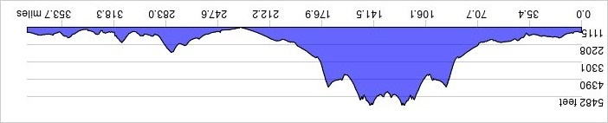


CONTROL 1: Hilton Garden Inn  1940 W Pinnacle Peak Rd, Phoenix  623.434.5556  Mile 0.0  Ride Starts @ 05:00 | Time:  (24 hour format)  05:00 |  |  | CONTROL 6: Quik Trip  11309 Grand Ave, Sun City  Mile 229.3  Open: 16:10; Close: 05:36 Sunday
CONTROL 2: Circle K  6802 E Cave Creek Rd. Cave Creek  Mile 21.6  Open: 06:02; Close: 07:20 | Arrival Time:  (24 hour format) |  |  | CONTROL 7: Hilton Garden Inn 1940 W Pinnacle Peak Rd, Phoenix  623.434.5556  Mile 247.8  Open: 17:06; Close: 07:36 Sunday
CONTROL 3: Burger King, Taco Bell / Shell gas  530 E Wickenburg Way, Wickenburg  Mile 74.5  Open: 08:32; Close: 13:00 | Arrival Time:  (24 hour format) |  |  | INFO CONTROL: Intersection of Cave Creek Rd  Mile 264.1  What color is the road?_________
CONTROL 4: OPEN:  ANY establishment on The "Square" in Prescott  Mile 134.4  Open: 11:23; Close: 19:24 | Arrival Time:  (24 hour format) |  |  | CONTROL 9: Chevron 13779 Fountain Hills Blvd, Fountain Hills  (or Any in this plaza)  Mile 296.7  Open: 19:42; Close: 12:48 Sunday
CONTROL 5: Burger King, Taco Bell / Shell gas  530 E Wickenburg Way, Wickenburg  Mile 193.9  Open: 14:23; Close: 01:48 Sunday" | Arrival Time:  (24 hour format) |  |  | CONTROL 10: Subway  N Power Rd, Ridgeview Plaza, Mesa  (or ANY establishment on this corner)  Mile 327.4  Open: 21:22; Close 16:08 Sunday
CONTROL 11: Hilton Garden Inn  1940 W Pinnacle Peak Rd, Phoenix  623.434.5556  Mile 375.0  Open: 23:48; Close: 21:00 Sunday | Time:  (24 hour format)
Arrival Time:
(24 hour format)
Arrival Time:
(24 hour format)
Arrival Time:
(24 hour format)
Arrival Time:
(24 hour format)

