RUSA Member #: Pending □  Last Name:  First Name:  Address:  Brevet medals can be ordered online at www.rusa.org.  Rider’s signature at the FINISH:  The ride was done in: _______ hours _______ minutes  Organizer’s signature:  Organizer’s Emergency Contact Info  Mike Sturgill  602.702.2132 |  |  | Brevet de Randonneurs Mondiaux    Scorpion 600KM  Organized by:  Phoenix Randonneurs  April 7, 2018  Phoenix, AZ  VERIFIED AND VALIDATED EXCLUSIVELY  BY  L’AUDAX CLUB PARISIEN
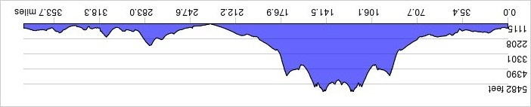


CONTROL 1: Red Roof Inn  17222 N Black Cyn Hwy, Phoenix  602.866.1049  Mile 0.0  Ride Starts @ 05:00 | Time:  (24 hour format)  05:00 |  |  | CONTROL 6: Quik Trip  11309 Grand Ave, Sun City  Mile 232.6  Open: 16:19; Close: 05:56 Sunday
CONTROL 2: Carefree Food Mart  7201 E Cave Creek Rd. Cave Creek  Mile 24.0  Open: 06:09; Close: 07:36 | Arrival Time:  (24 hour format) |  |  | CONTROL 7: Red Roof Inn  17222 N Black Cyn Hwy, Phoenix  602.866.1049  Mile 248.1  Open: 17:06; Close: 07:36 Sunday
CONTROL 3: Burger King, Taco Bell / Shell gas  530 E Wickenburg Way, Wickenburg  Mile 77.7  Open: 08:41; Close: 13:20 | Arrival Time:  (24 hour format) |  |  | CONTROL 8: Circle K  10989 E Dynamite Blvd, Scottsdale  480.502.0446  Mile 277.4  Open: 18:40; Close: 10:44 Sunday
CONTROL 4: OPEN:  ANY establishment on The "Square" in Prescott  Mile 137.5  Open: 11:32; Close: 19:44 | Arrival Time:  (24 hour format) |  |  | CONTROL 9: Chevron 13779 Fountain Hills Blvd, Fountain Hills  (or Any in this plaza)  Mile 298.9  Open: 19:50; Close: 13:04 Sunday
CONTROL 5: Burger King, Taco Bell / Shell gas  530 E Wickenburg Way, Wickenburg  Mile 197.1  Open: 14:32; Close: 02:08 Sunday" | Arrival Time:  (24 hour format) |  |  | CONTROL 10: Subway  N Power Rd, Ridgeview Plaza, Mesa  (or ANY establishment on this corner)  Mile 329.7  Open: 21:30; Close 16:24 Sunday
CONTROL 11: Red Roof Inn  17222 N Black Cyn Hwy, Phoenix  602.866.1049  Mile 376.5  Open: 23:48; Close: 21:00 Sunday | Time:  (24 hour format)
Arrival Time:
(24 hour format)
Arrival Time:
(24 hour format)
Arrival Time:
(24 hour format)
Arrival Time:
(24 hour format)

